Exercise “Snacking”

This easy to follow programme involves short bursts of moderate exercise for you to ‘snack’ on throughout the day. These small amounts of exercise are so short they can fit easily into your busy day and can increase fitness, support weight loss and help with the prevention of heart disease and diabetes by stabilizing blood sugar levels.
The exercises don’t require any special equipment or gym wear – just the timer function on your watch or phone to time your sets!

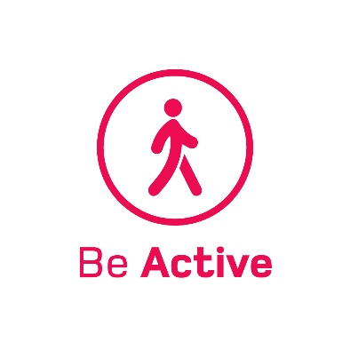
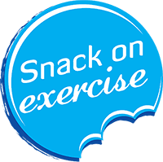

TIME | EXERCISE |  | REPS
10.00am | Jog or March on the spot | 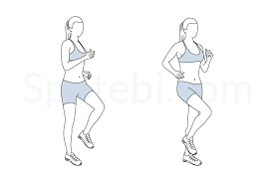 | 5 x sets of 20 with a 15 second break
11.00am | Squats | 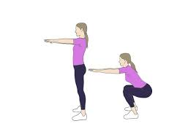 | 5 x sets of 10 with a 15 second break
12 noon | Arm Circles |  | 2 x sets of 20 forward  2 x sets of 20 backwards  15 second break between sets
1.00pm | One leg standing | 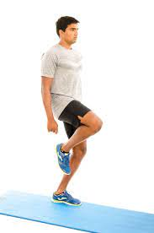 | 2 x 20 seconds on each leg with a 15 second break
2.00pm | Desk tri dips | 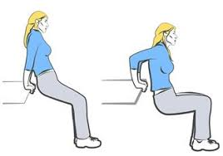 | 4 x sets of 20 with a 15 second break
3.00pm | Desk push ups | 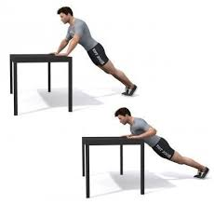 | 5 x sets of 20 with a 15 second break
4.00pm | Jog or March on the spot |  | 5 x sets of 20 with a 15 second break

